**NAME – KUNTAL MONDAL**

**DEPARTMENT- CSE (SEM- 5TH,SEC-A)**

**ENROLLMENT NO- 2011200001029**

**REGISTRATION NO- 200010298425**

SE ASSIGNMENT-1(B)

**(B) An annual general meeting of a large company will be held on 25th August,2014.**

List of activities:

a) Book the meeting space.

b) Schedule speakers.

c) Arrange for audio-visual equipments.

d) Order food.

e) Send out invitation

f) Mail out annual report.

**Details task analysis under order food:**

d. 1) Create a budget.

d.2) Determine a menu.

d.3) Select a caterer.

d.3.1) Send out request for bids.

d.3.2) Receive all estimates.

d.3.3) Review estimates and award contract.

d.4) Give final head count to caterer.

d.5) Confirm menu one week before the meeting.

**Draw the Gantt chart and determine the finish date.**

**GANNT CHAT-**

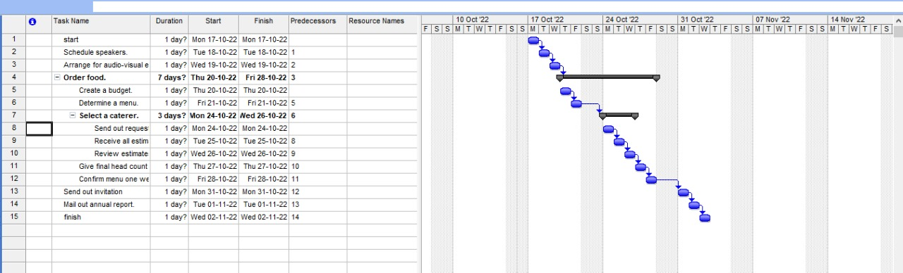

**NETWORK DIAGRAM -**

